Abstract:

In crowds of thousands of people moving on a daily basis, situations can worsen in a matter of seconds. The current existing security surveillance systems need a shift from existing reactive incident detection which works either during or post the event to detect any sense of violence.
Most of the state of art models as or after violence happens ( $Δt=0),$offering little time for security intervention. This paper proposes a lightweight multimodal based proactive hazard forecasting that finds its purpose in the pre-event. Only video or audio models can suffer high false positive rates due to occlusion and jitter. The pre-existing violence detection and prediction approaches require heavy memory and compute powers, making it very difficult to be used in edge devices.The early warning framework discussed in the paper is a parallel multi-stream pipeline that combines spatio-temporal video stream for behavioral analysis, acoustic anomaly analyser for shouts and screams, and objector detector for checking any possession of any firearms or weapons. Using an attention-based crossed modal feature concatenation, a predictive score is calculated. This approach also rejects use of any 3D CNNs, that might be heavy to run and implements model quantization for an edge optimised pipeline.

Introduction:

With the rise in urban crowd movement, it doesn't take more than a second for any normal public passage to turn into a scene of violence. These situations require immediate intervention of security institutions, which often becomes a rough task provided the timeline of the event series. The damage done in the time between receiving the information about violence and the right institutions arriving, is a lot. There is establishment of Closed-Circuit Televisions (CCTVs) in a huge amount all around such public places and around [1]. These serve the important purpose of capturing and monitoring the movements of crowds. However, these rely on manual operation. With data coming in every second and each street having multiple angles being captured, manual surveillance is a very unscalable, expensive and error prone task [2]. Hence, with developments in Computer Vision models (CV) and Deep Learning approaches, this task can be automated to be able to detect and predict any form of upcoming violence. Thus, this can strengthen the public safety monitoring system.
The existing state of the art systems heavily rely on a reactive approach that aims to be able to detect any happening or happened violence. This does not contribute enough to the prevention or early action being taken on such events, and the problem exists as it was, because security personnels are alerted too late leaving zero lead time. This paper highlights an approach that works by combining Computer Vision and Deep Learning to produce a violence predictor that is capable of detecting and predicting any chances of occurrence of violence in the future. This would operate in the pre-event phase ( $Δ$t < 0 ) with a measurable lead time metric.
Transitioning from reactive detection to proactive hazard forecasting introduces significant technical hurdles. The existing detection models work with unimodal surveillance pipelines, i.e., these are either video only [3] or audio only [4] approaches. These suffer high false positive rates due to visual occlusion, camera jitter, light shifting or ambiguous movements like hugging, sports or normal social contacts. Audio only approaches, based on the screams and shouts which without the right context can be wrongly predicted to be signs of violence [4]. Not just that, standard video models rely on 3D Convolutional Neural Networks ( CNNs ) or heavy video transformers [5]. These models are computationally very heavy to load and process. This acts as a major blocker in the domain of model based surveillance. Their heavy nature makes it almost impossible to be run on resource-constrained edge devices like smart CCTV cameras. Existing threat detectors, focus exclusively on handguns and firearms ignoring cold weapons like knives, swords, and others, along with multiple blunt objects that might be used as an instrument for harming others [6]. This shows the presence of a structural bias towards certain kinds of tools.
- To address these limitations, this paper proposes an edge-optimized, parallel multi-stream deep learning framework for proactive violence prediction and weapon threat forecasting. The implementation incorporates a lightweight spatio-temporal visual backbone [7], instead of relying on 3D convolutions that have high computational overhead. The visual backbone is augmented with a custom 3D spatial and temporal self attention mechanism, so that it can capture subtle behavioral anomalies without any memory overhead. An acoustic anomaly detector works in parallel, to the behavioural analyser that checks for anomalies in audio. It involves mel-spectrogram extraction and then processing them using a CNN-LSTM based model. It has the ability to detect distress patterns in vocal using a learnt fall back embedding system to ensure that it is robust even when there is no audio or it is compromised. There is an object detector that has been fine-tuned which uses YOLOv8 [8] to detect possession threats in different objects such as firearms, cold arms and blunt instruments. It does this while ensuring minimal confusion in objects.
- Applications:
The project focuses on applications of video analysis technology for public safety purposes, in particular the following use cases should be considered:
1. An early warning system using CCTV cameras in which the increase in the likelihood of the occurrence of violent events in time instead of the final label will serve as a trigger for an escalating alert before the fight actually breaks out.
2. Multimodal event detection in which the combination of vision and audio features (for example, yelling) will result in fewer false positives from the purely visual detector while an independent weapon detector will provide a complementary signal not accounted for by visual-only violence detectors.
3. A low-resource setting because the architecture does not utilize large 3D-CNN or transformers but prefers smaller frozen/nano-sized backbones.
4. Incident forensics after the fight, where an explanation in terms of per-frame probability curve and related escalation metrics (crossing point, escalation rate, strict escalation pattern) is provided instead of just a label.
- Challenges Faced:
1. Video processing issues: The presence of corrupted or unreadable files, non-UTF-8 filenames resulting in extraction failures, and frames per clip varying in both resolution and count necessitated error checking, standardization of sample size to 16 frames, and resizing and color correction. Visual ambiguity caused by factors such as occlusion, camera shake, low lighting, and crowd density, along with the computational expense of decoding and extracting features for thousands of clips, made caching to disk desirable.
2. Audio processing issues: one of the primary datasets (RWF-2000) had no audio component whatsoever (confirmed using ffprobe) [3], and even videos with audio had either silent or near-silent waveforms and varying lengths which led to silence detection, constant length normalization/padding and Mel-spectrogram framing of fixed size; videos with no audio components had has_audio flag set to 0 and used learned fallback embedding.
3. Class and category imbalances: violence classification model used weighted loss based on class ratios, and weapon detection model used the merging of under-represented sub-categories of firearms (shot-gun, submachine-gun) into Rifle category.
4. Data leakage risk: naive approach of clip-level splitting had risk of same source video/camera showing up in training/validation/testing sets, solved through source level splitting (based on source_id), with leakage verified explicitly.
5. Data scope and suitability constraints : processing entire dataset was computational infeasible, so subsampling based on class balance was done rather than using it exhaustively; Abuse category in XD-Violence dataset was removed post review as it had sexually explicit content not within the scope of this study.
The rest of the paper is organized as follows. Section 2 reviews the prior work behind each part of the proposed architecture. Section 3 covers the methodology, including the datasets, preprocessing pipeline, backbone architecture, hyperparameter setup, and technical implementation. Section 4 presents the results and analysis across all four datasets, covering violence recognition, weapon threat detection, escalation forecasting, and the resulting probability trajectory.
2. LITERATURE REVIEW
This section reviews prior work informing the design of each backbone/module in the proposed multimodal violence-prediction pipeline: the spatial backbone (MobileNetV3-Small), the residual baseline (ResNet-18), the spatiotemporal baseline (R(2+1)D-18), the weapon-detection module (YOLOv8), the recurrent temporal aggregators (Bi-GRU/Bi-LSTM), and the cross-modal fusion mechanisms combining the video, audio, and weapon-threat streams. Table 2.1 summarises all reviewed papers.

2.1 MobileNetV3-Small
The MobileNet family established depthwise-separable convolutions [9], inverted residual bottlenecks [10], and hardware-aware NAS with h-swish activation [11] — the variant adopted directly as this project’s frame-level backbone. A related lightweight design uses pointwise group convolution with channel shuffling [12]. Violence-specific lightweight networks build on such backbones with temporal shift modules [13], pruned spatial-temporal frameworks [14], embedded CNN-GRU pipelines [15], and MBConv-based motion attention [16], together supporting the choice of a MobileNetV3-style backbone for this project.

2.2 ResNet-18
ResNet introduced identity shortcut connections to overcome the degradation problem in very deep networks, directly defining the ResNet-18 backbone used here [17]. Extensions include recurrent residual blocks for spatio-temporal reasoning [18], skeleton-to-image action recognition [19], and refined information-flow/residual/projection designs [20]. A survey confirms ResNet-18’s transferability across domains [21], while a person re-identification study found ResNet-18 converges faster than deeper variants at a modest accuracy cost, motivating its use as the comparison baseline [22]. Attention-augmented ResNet-18 variants further show compatibility with lightweight channel/spatial attention, informing this project’s fusion design [23].

2.3 R(2+1)D-18
Early spatiotemporal baselines include 3D CNNs (C3D) [24] and two-stream RGB/optical-flow networks [25]. R(2+1)D [26], which factorises 3D convolution into 2D-spatial-plus-1D-temporal steps, is used directly as this project’s Kinetics-pretrained spatiotemporal baseline; I3D [27] established the Kinetics-pretraining strategy applied here. R(2+1)D has since been adapted to sensitive-content classification [28] and two-stage person-detection-then-3D-CNN violence pipelines [29], the latter closely mirroring this project’s keyframe-based design. RWF-2000 [30] supplies one of the project’s core training datasets alongside a comparable 3D-CNN/optical-flow baseline.

2.4 YOLOv8 (Weapon Detection)
Several studies pair YOLOv8 with auxiliary stages — feature-selection classifiers [31], segmentation/refinement networks [32], and alert-triggering pipelines [33] — for real-time CCTV weapon detection, directly informing this project’s alert-triggering weapon branch. Comparative benchmarks confirm YOLOv8’s favourable speed-accuracy trade-off against RetinaNet/EfficientDet [34] and its suitability for deployment-oriented, public-safety screening [35]. Fine-tuning studies report class confusion between visually similar weapons [36], motivating the taxonomy consolidation used here, while a cross-configuration study [37] informed this project’s confidence-thresholding strategy.

2.5 Bi-GRU / Bi-LSTM (Temporal Aggregation)
The GRU [38] is used directly as the recurrent building block for temporal aggregation in this project. CNN-recurrent hybrids combining 1D-CNN with LSTM/GRU ensembles [39] and CNN-then-GRU spectrogram pipelines [40] mirror the acoustic branch design. Benchmarking across GRU, Bi-GRU, LSTM, and Bi-LSTM [41] shows consistent gains from bidirectionality, supporting the use of bidirectional recurrent layers in both video and audio branches — reinforced by bidirectional-LSTM speech-emotion models [42], modality-specific GRU/Bi-LSTM fusion for mental-health classification [43], attention-guided CNN-BiLSTM designs informing regularisation choices [44], and depth/pooling comparisons for bidirectional LSTMs [45].

2.6 Cross-Modal Attention / Multimodal Fusion
Multi-branch fusion of RGB, audio, and optical-flow with channel attention [46], and bi-directional cross-modal attention that treats modalities symmetrically [47], directly parallel this project’s fusion module. Alignment-before-fusion approaches [48] relate to the fixed 16-keyframe synchronisation used here, while adaptive modality-weighting via hyperbolic attention [49] supports the project’s gated modality-weighting scheme. An asymmetric, audio-guided attention design [50] was considered as an alternative fusion strategy, and a three-modality (RGB/audio/pose/flow) attention-and-gating network [51] is directly relevant to this project’s three-stream video/audio/weapon fusion problem. Finally, cross-modal attention generalises well to heterogeneous, misaligned modalities in audio-visual deepfake detection [52], reinforcing the overall fusion design rationale.
Table 2.1: Summary of Reviewed Literature by Model
Model | Paper (Ref) | Approach & Key Result
MobileNetV3-Small | [9] MobileNets: Efficient Convolutional Neural Networks for Mobi… | Depthwise-separable convolutions (per-channel + pointwise filters); Width multiplier α, resolution multiplier ρ; 70.6% top-1, 569M FLOPs
MobileNetV3-Small | [10] MobileNetV2: Inverted Residuals and Linear Bottlenecks | Inverted residual blocks + linear bottleneck; 72.0% top-1 accuracy, 300M MAdds
MobileNetV3-Small | [11] Searching for MobileNetV3 | Hardware-aware NAS + NetAdapt + h-swish activation + squeeze-excite block; Width multipliers 0.35-1.25; 75.2% top-1 (Large), 219M MAdds
MobileNetV3-Small | [12] ShuffleNet: An Extremely Efficient Convolutional Neural Net… | Pointwise group convolution + channel shuffle; Group number g, complexity multiplier
MobileNetV3-Small | [13] Lightweight Mobile Network for Real-Time Violence Recogniti… | MobileNetV2 backbone + Temporal Shift Module (TSM); Model size 8.49 MB; accuracy 97.96% / 97.5% / 87.75% across three datasets
MobileNetV3-Small | [14] Vi-SAFE: A Spatial-Temporal Framework for Efficient Violenc… | YOLOv8s + GhostNetV3 backbone + EMA attention + model pruning; Pruning for reduced parameters/FLOPs; edge-latency optimised
MobileNetV3-Small | [15] An Embedded Deep Learning Framework for Real-Time Violence… | Compact CNN spatial encoder + GRU temporal aggregator + alert generation; Optimised for sub-real-time inference on embedded hardware
MobileNetV3-Small | [16] Lightweight Violence Detection Model Based on 2D CNN with B… | EfficientNet-B0 backbone (MBConv blocks) + bi-directional motion attention; NAS-based compound scaling (from EfficientNet family)
ResNet-18 | [17] Deep Residual Learning for Image Recognition | Identity shortcut connections; 18/34/50/101/152-layer variants; SGD optimisation, standard ImageNet training schedule
ResNet-18 | [18] Recurrent Residual Learning for Action Recognition | ResNet + recurrent connections between residual blocks; Limited-range temporal context window (local frame range)
ResNet-18 | [19] Learning and Recognizing Human Action from Skeleton Movemen… | 3D joint coordinates → RGB-image encoding → ResNet classification; Five ResNet-based model variants compared
ResNet-18 | [20] Improved Residual Networks for Image and Video Recognition | Improved information flow, residual block, and projection shortcut; 404-layer ImageNet model; 3002-layer CIFAR model
ResNet-18 | [21] A Comprehensive Review of ResNet-18: Architecture and Appli… | Literature survey of ResNet-18 architectural adaptations; Not applicable (survey paper)
ResNet-18 | [22] Deep Residual Network and Transfer Learning-based Person Re… | Two-step fine-tuning across ResNet-18/34/50, ResNeXt-50; ResNet-18: faster convergence, comparatively higher error rate
ResNet-18 | [23] Systematic Integration of Attention Modules into CNNs for A… | SE-ResNet18 v1/v2 variants (SE and spatial-attention blocks); Channel-attention + spatial-attention integration into BasicBlocks
R(2+1)D-18 | [26] Learning Spatiotemporal Features with 3D Convolutional Netw… | 3×3×3 convolutional kernels; 8 conv + 5 pooling layers; Generic transferable video features across tasks
R(2+1)D-18 | [28] Two-Stream Convolutional Networks for Action Recognition in… | Separate RGB and optical-flow CNN streams, late (softmax) fusion; Score averaging across RGB and flow streams
R(2+1)D-18 | [25] A Closer Look at Spatiotemporal Convolutions for Action Rec… | 2D spatial conv followed by 1D temporal conv (per block); Intermediate channel size M_i chosen to match 3D parameter count
R(2+1)D-18 | [27] Quo Vadis, Action Recognition? A New Model and the Kinetics… | 2D Inception filters inflated to 3D; RGB + optical-flow streams; 80.9% HMDB-51, 98.0% UCF-101 after Kinetics pretraining
R(2+1)D-18 | [29] Spatiotemporal CNNs for Pornography Detection in Videos | R(2+1)D backbone adapted for binary video classification; (2+1)D decomposition for improved compute efficiency vs. full 3D
R(2+1)D-18 | [30] Violence Detection Using Spatiotemporal Features with 3D Co… | MobileNet-SSD person detector → 16-frame sequence → 3D CNN → Softmax; Fixed 16-frame input sequence length
R(2+1)D-18 | [31] RWF-2000: An Open Large-Scale Video Database for Violence D… | Learned gating mechanism fusing 3D-CNN and optical-flow features; ~86.75-87.25% accuracy on RWF-2000
YOLOv8 (Weapon Detection) | [32] Weapon Detection in Surveillance Videos Using YOLOV8 and PE… | YOLOv8 detection + PELSF-DCNN refinement, alarm trigger; Real-time deployment target for CCTV alerting
YOLOv8 (Weapon Detection) | [33] Real Time Weapon Detection using YOLOv8 and Alert Mechanism | End-to-end YOLOv8 detection with alert-mechanism trigger; Low-cost, real-time inference target
YOLOv8 (Weapon Detection) | [34] Weapon Detection with FMR-CNN and YOLOv8 for Enhanced Crime… | Region refinement + instance segmentation + fast detection; Confidence-score-based severity scoring
YOLOv8 (Weapon Detection) | [35] Gun Detection: A Comparative Study of RetinaNet, EfficientD… | RetinaNet vs. EfficientDet vs. YOLOv8 benchmarking; Accuracy / inference-speed comparison across detectors
YOLOv8 (Weapon Detection) | [36] Real-Time Weapon Detection Using YOLOv8 for Enhanced Safety | YOLOv8 fine-tuning for public-safety screening; Deployment-oriented evaluation across weapon categories
YOLOv8 (Weapon Detection) | [37] Deep Learning-based Weapon Detection using Yolov8 | Fine-tuning on custom 2-class annotated dataset; mAP@0.5 = 0.852, mAP@0.5:0.95 = 0.622, P = 0.89, R = 0.80
YOLOv8 (Weapon Detection) | [38] A Comprehensive Study for Weapon Detection Technologies for… | Cross-configuration benchmarking of YOLOv8 variants; Reliability assessment under real-world conditions
Bi-GRU / Bi-LSTM (Temporal Aggregation) | [39] Learning Phrase Representations Using RNN Encoder–Decoder f… | Reset and update gates; no separate memory cell (unlike LSTM); Fewer parameters than LSTM for comparable performance
Bi-GRU / Bi-LSTM (Temporal Aggregation) | [40] An Ensemble 1D-CNN-LSTM-GRU Model with Data Augmentation fo… | 1D CNN + LSTM + GRU ensemble with data augmentation; Ensemble combination of complementary recurrent cells
Bi-GRU / Bi-LSTM (Temporal Aggregation) | [41] Building Emotion Identification System from Speech Using CN… | Spectrogram CNN feature extraction → GRU temporal modelling; ~97% classification accuracy
Bi-GRU / Bi-LSTM (Temporal Aggregation) | [42] AVAR-Net: A Lightweight Audio-Visual Anomaly Recognition Fr… | Wav2Vec2 features + GRU / Bi-GRU / LSTM / Bi-LSTM / Transformer / MTCN comparison; MTCN best (72.10% on VAAR); Bi-LSTM > LSTM > GRU consistently
Bi-GRU / Bi-LSTM (Temporal Aggregation) | [43] ArabEmoNet: A Lightweight Hybrid 2D CNN-BiLSTM Model with A… | Convolutional layers → Bi-LSTM → attention; Lightweight design; forward/backward hidden-state concatenation
Bi-GRU / Bi-LSTM (Temporal Aggregation) | [44] Automatic Depression Detection: An Emotional Audio-Textual… | GRU (audio) + Bi-LSTM+attention (text) → modal-attention fusion; GRU: hidden size 256, 2 layers, dropout 0.5
Bi-GRU / Bi-LSTM (Temporal Aggregation) | [45] Enhanced Speech Emotion Recognition with Efficient Channel… | Attention-based local feature blocks (ALFB) + global feature block (GFB); 97% / 93% / 92% accuracy across the three datasets
Bi-GRU / Bi-LSTM (Temporal Aggregation) | [46] Deep Neural Networks for Emotion Recognition Combining Audi… | Bidirectional LSTM + global average pooling; Comparison of pooling strategies and network depth
Cross-Modal Attention / Multimodal Fusion | [47] Optical Flow-Aware-Based Multi-Modal Fusion Network for Vio… | RGB + audio + optical-flow branches, cross-modal fusion + channel attention; Score-fusion combining multiple modality branches
Cross-Modal Attention / Multimodal Fusion | [48] A Cross-modal and Redundancy-reduced Network for Weakly-Sup… | Relation-aware module + bi-directional cross-modal attention; Redundancy and semantic-noise reduction between modalities
Cross-Modal Attention / Multimodal Fusion | [49] Aligning First, Then Fusing: A Novel Weakly Supervised Mult… | Multi-scale attention alignment → temporal relational encoding; Coarse-to-fine semantic fusion across modalities
Cross-Modal Attention / Multimodal Fusion | [50] Cross-Modal Fusion and Attention Mechanism for Weakly Super… | Adaptive modulation fusion + Lorentzian (hyperbolic) attention; Hierarchical normal/abnormal relationship modelling
Cross-Modal Attention / Multimodal Fusion | [51] Audio-guided attention network for weakly supervised violen… | Audio features guide/reweight visual features (asymmetric); Asymmetric (audio-guided) fusion design
Cross-Modal Attention / Multimodal Fusion | [52] Multi-Modal Fusion Techniques for Detecting Abnormal Events… | Modality-wise Feature Matching Subspace (MFMS) + Cross-Modal Attention (CMA); 84.98% Average Precision on XD-Violence
Cross-Modal Attention / Multimodal Fusion | [53] Contextual Cross-Modal Attention for Audio-Visual Deepfake… | Attention over multi-modal, multi-sequence representations; +3.47% accuracy, +2.05% precision over prior published methods

3) Methodology

3.1 Datasets:

- RWF-2000
This data was acquired from Kaggle (https://www.kaggle.com/datasets/vulamnguyen). The said dataset consists of real-life videos categorized as either fight or nonfight in the .avi format, divided in an intrinsic 800/200 train/validation split per category (possibly 1000 videos of fight and 1000 videos of nonfight). After extracting the zip file, there were successfully 988 videos of fight and 1000 videos of nonfight (12 videos could not be extracted since their filenames contained characters from a non-UTF-8 character set). With the help of ffprobe, it was discovered that there is no audio component on the videos of the RWF-2000 dataset.
The existence of two parts such as fight and non-fight videos would help us in having a balanced dataset, so that the model we would create would not classify usual scenes like two people talking or a normally operating supermarket as violent scenes.
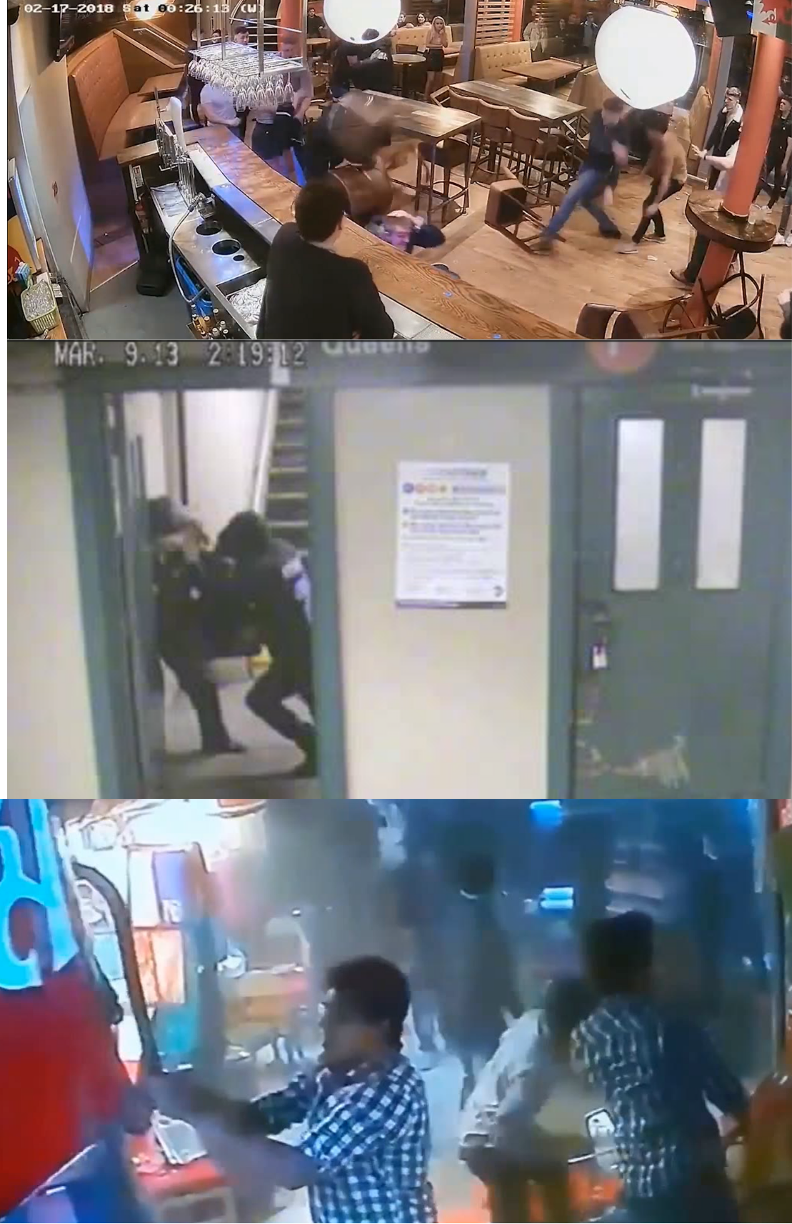
Fig 3.1. Snippets from the surveillance videos from the fight repositories under the training and validation dataset.
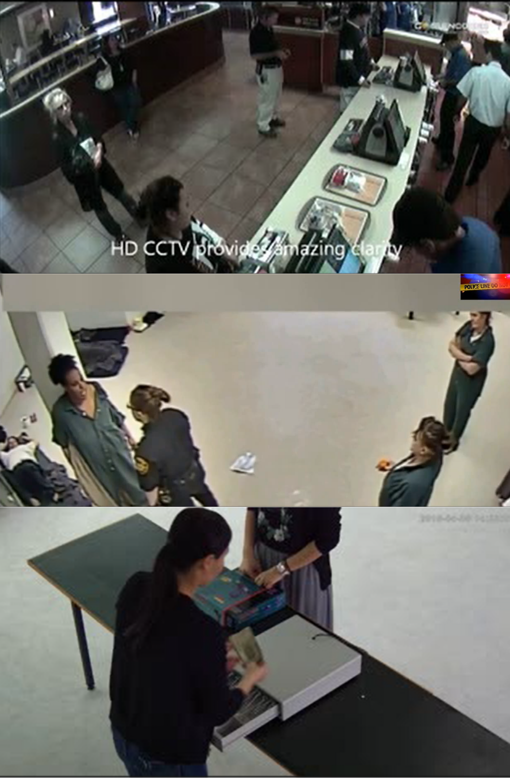
Fig 3.2: Snippets of surveillance videos from the non fight video repository under the training and validation datasets.
- RLVS - Real life video surveillance :
Obtained from Kaggle (mohamedmustafa/real-life-violence-situations-dataset), RLVS includes .mp4 files categorized as Violence and NonViolence. According to the dataset providers, this dataset contains videos obtained from youtube. This video shows street fight scenes in an actual environment. The non-violence videos contain normal day-to-day activities of humans including walking, eating, playing music and more. This dataset includes 1000 videos of violence and 1000 videos of non-violence.
As opposed to RWF-200, there are some videos that have synchronized acoustic streams. The audio stream is extracted via librosa as 64-band Log-Mel Spectrograms for training of the CNN-BiLSTM acoustic anomaly encoder.
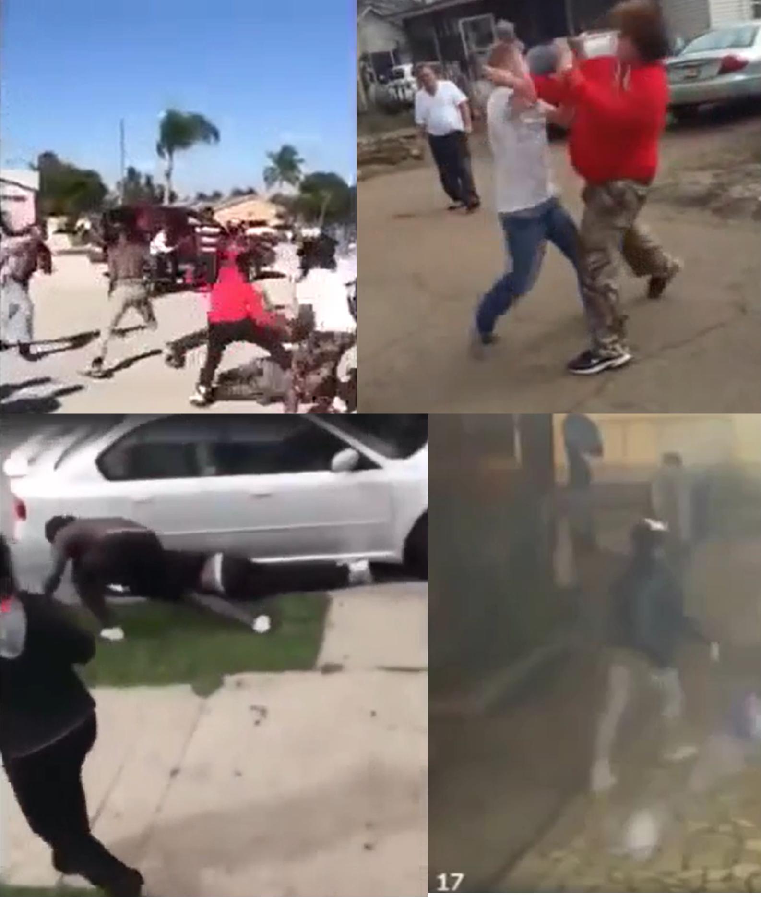
Fig 3.3. Snippets of the violence videos from the Violence video archival of the dataset.
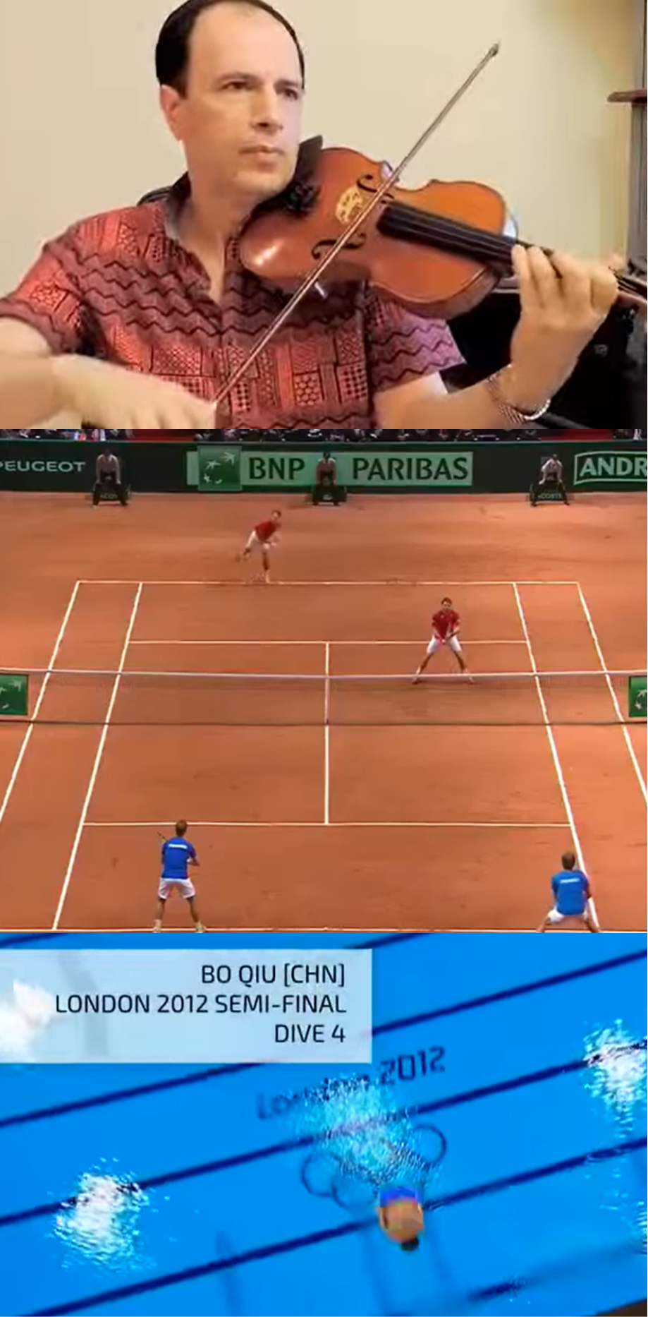
Fig 3.4. Snippets of the normal human action videos from the Non-Violence video archival of the dataset.
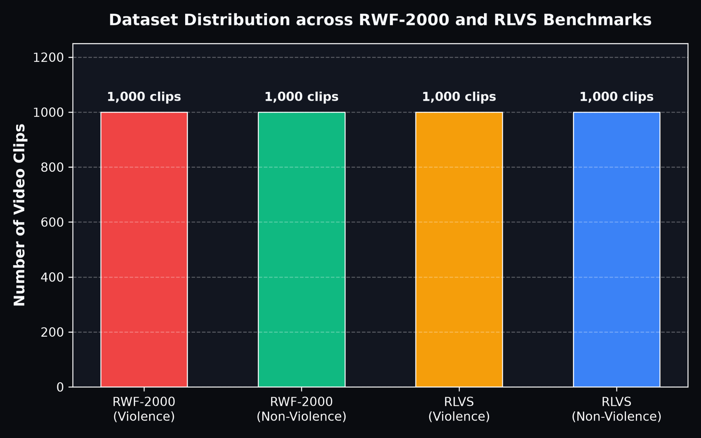
Fig 3.5: Class distribution across RWF-2000 and RLVS dataset benchmarks.
- YOLO Weapon Detection Dataset :
An additional image dataset with weapons was collected separately from the Roboflow API for the workspace weapon-detect-qbsiw and project yolo-weapon-detection, version 1 in YOLOv8 annotation format. The dataset contained 1,478 images for the training phase, 316 images for validation and 318 images for testing. It is important to note that code comments inlined throughout the following describe the initial classification scheme with five classes (Rifle, knife, pistol, shot-gun, submachine-gun); nevertheless, the subclasses shot-gun and submachine-gun, which belonged to the firearm superclass, were poorly represented in the validation set (5 and 1 examples, respectively) and therefore were combined with the rifle class, leading to the final three-class taxonomy (Rifle, knife, pistol, nc = 3).
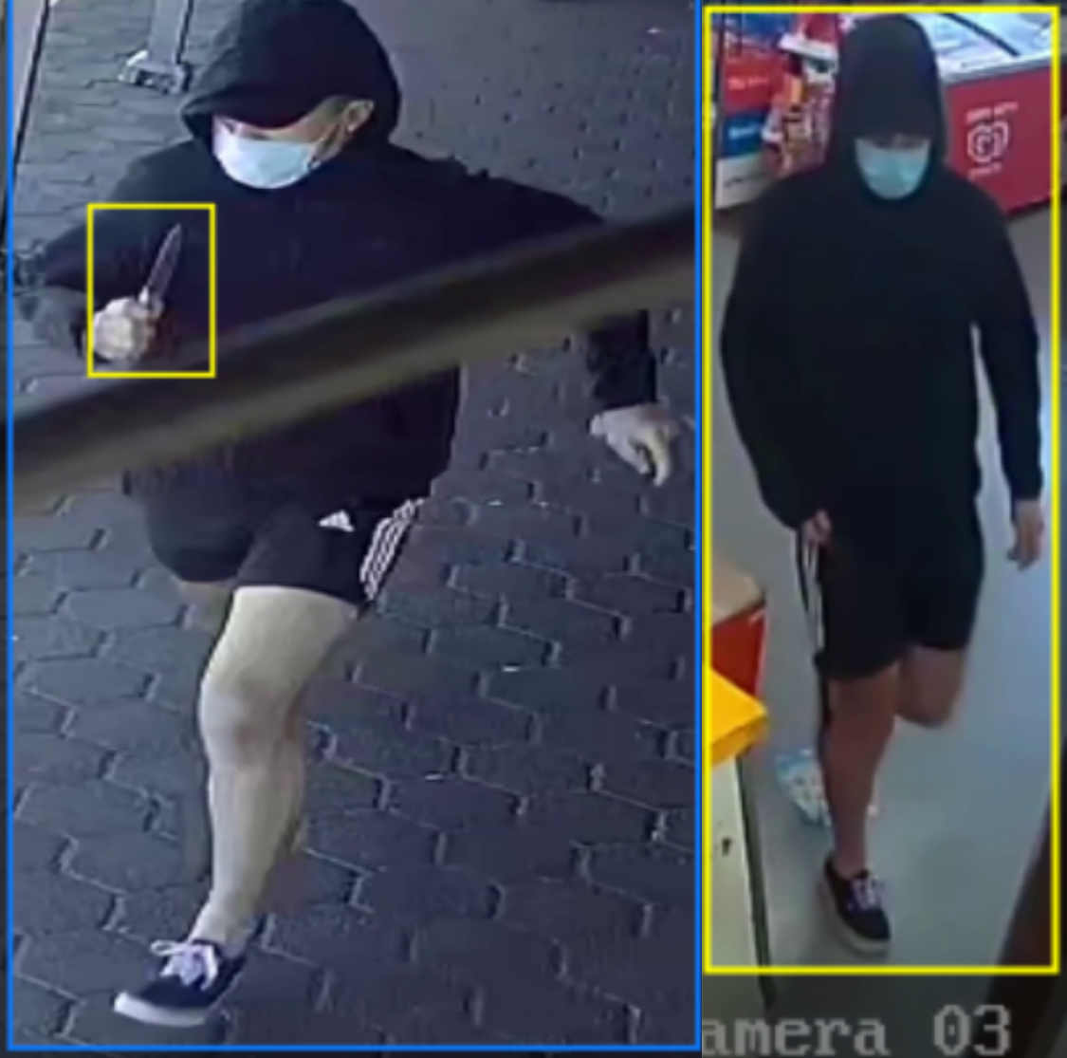
Fig 3.5. Images from the dataset classifying various different weapons.

- XD-Violence :
Together with RWF-2000 and RLVS datasets, the current study uses XD-Violence Single-Label Edition dataset (https://www.kaggle.com/datasets/bypktt/xd-violence) that comes pre-split into ‘train’/ ‘test’ directories, containing seven classes: Abuse, CarAccident, Explosion, Fighting, Normal, Riot, and Shooting.
Class ‘Abuse’ was left out of analysis because, upon inspection, some of its videos included sexually explicit content, which was outside the scope of the current study. It was omitted from both subsets.
Of the remaining six classes, ‘Normal’ was labeled as non-violent (0), while ‘CarAccident’, ‘Explosion’, ‘Fighting’, ‘Riot’, and ‘Shooting’ classes as violent (1).
Due to the large number of data points in the complete XD-Violence dataset and the computational cost associated with feature extraction on frame level for all clips from the dataset using ResNet18, the entire dataset could not be used in the current study. An equal subset of video clips was extracted from each of the remaining six classes (train/test separately).
Just as in the case with two other datasets, splitting of the data at the source level was done (seed = 42, 70/15/15, checked for leakage), and 16 frames from each clip were extracted uniformly and scaled for input into the frozen ResNet18 feature extractor
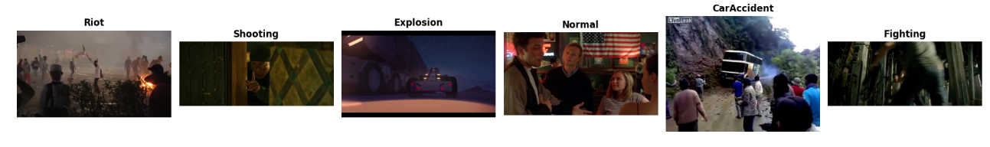

Figure 3.6. Snippets of videos from the Car Accident, Explosion, Fighting, Normal, Riot, and Shooting classes of the mentioned dataset.

3.2 Data Preprocessing:

3.2.1 Preprocessing Visual Spatio-Temporal Features
Video is heavy, and edge hardware doesn't have the memory or time to chew through every frame. So before anything else touches the network, each clip gets boiled down to a fixed set of 16 keyframes, spread evenly across its length. For a clip with N total frames, the index of the $i_{th}$ keyframe (where i runs from 0 to 15) is :
$I\left(i\right)=\frac{i⋅N_{total}}{16}$……(1)
Once we have those 16 frames, each one gets resized down to 112×112 pixels and normalized using the usual ImageNet statistics mean (0.485,0.456,0.406) and standard deviation (0.229,0.224,0.225) across the RGB channels.
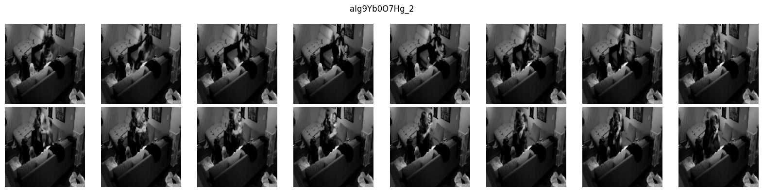
Fig 3.7 : Splitting of a video set into 16 frames
Extraction went cleanly across both datasets. RWF-2000 gave us 1,988 usable clips out of 1,988 valid ones (we had to drop 12 archive files that wouldn't extract because of bad character encoding, but that's a filesystem quirk, not a video problem). RLVS came through with all 2,000 clips intact and zero errors there.
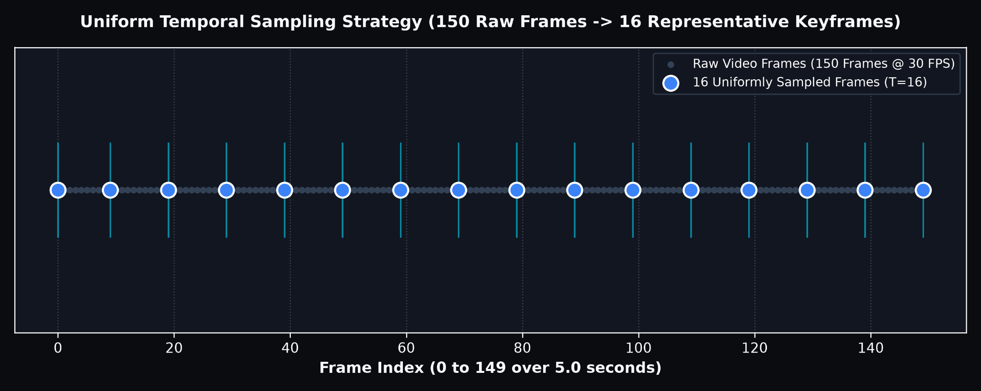
Fig 3.8: Uniform temporal sampling strategy (150 raw frames $→$ 16 keyframes).
3.2.2 Splitting the Data and Putting It Together
The same rules apply to RLVS as well, but we handled them differently.
RWF-2000 already ships with its own train and validation split, so we left that exactly and didn’t reinvent it any more. After filtering out a few broken clips, we had 1,588 training clips and 400 validation clips. RLVS doesn’t come with a split at all, so we made our own: an 80/20 division at the video level (seed 42, so it’s reproducible), making sure that every frame from a video was on one side of the split, since we don’t want frames from the same clip to leak between train and validation.
Once both were split, we glued them together with PyTorch’s ConcatDataset. That gives us 3,188 clips for training (1,588 from RWF-2000 + 1,600 from RLVS) and 800 for validation (400 + 400).

Table 3.1: How the combined dataset breaks down
Partition | RWF-2000 | RLVS | Total | Clips w/ valid audio | Clips using fallback
Training | 1,588 | 1,600 | 3,188 | 702 (22.0%) | 2,486 (78.0%)
Validation | 400 | 400 | 800 | 191 (23.9%) | 609 (76.1%)
Total | 1,988 | 2,000 | 3,988 | 893 (22.4%) | 3,095 (77.6%)

3.2.3 Audio Extraction & Missing-Modality Fallback Strategy

RWF-2000 clips are silent, there's simply no audio track to work with, so acoustic processing only applies to RLVS.
For clips that do have sound, we pulled a 3-second window at a 22,050 Hz sample rate
and ran it through an STFT(Short-time Fourier Transform) to get a 64-band log-Mel spectrogram, $S_{mel}∈R^{64×130}$ then converted the power values to decibels:
$S_{dB}\left(f,t\right)=10\log_{10}\left(\frac{S_{mel}(f,t)}{max⁡(S_{mel})}\right)$……(2)
$S_{dB}$​ (f, t) is the loudness value (in decibels) at frequency band f and time frame t.
$S_{mel}$ (f, t) is the raw energy at that same spot before conversion, and $\text{max(}S_{mel})$ is the loudest value anywhere in the clip (used as a reference point).
But not all of the clips came through. Of the 1,951 candidate RLVS videos (1,000 violent and 951 non-violent), some had no audio stream at all, and others were silent with total energy below ${10}^{-5}$ so we discarded them too. Only 893 were able to produce a spectrogram with audio; the others were flagged as audio-absent. That’s a lot of audio missing from roughly three-quarters of the training set (2,486 of 3,188 clips) and a similar amount of validation (609 of 800). Rather than throw away those clips or put them into a placeholder and ignore them, we let the model learn a placeholder itself. A trainable fallback vector $e_{fallback}∈R^{128}$ steps in whenever audio is missing, gated by a binary flag $m_{audio}$:
$a_{final}=m_{audio}*a_{embed}+(1-m_{audio})*e_{fallback}$ ……(3)
where $a_{embed}$ represents the audio embedding obtained using the Mel-spectrogram of those audio clips having an active audio stream, whereas $a_{final}∈R^{128}$ is the resulting 128-dimensional audio representation passed forward for fusion, computed by gating between $a_{embed}$ and $e_{fallback}$ based on $m_{audio}$.
So when audio exists, the model uses it; when it doesn't, the model falls back on a learned "default" representation instead of a hole in the input.
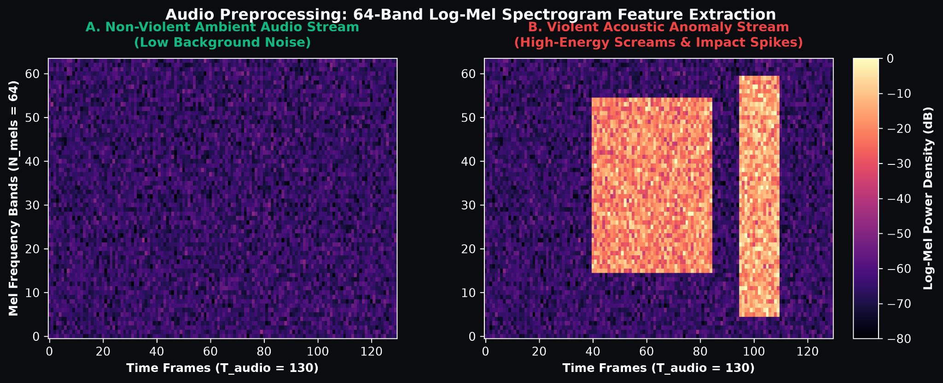
Fig 3.9: 64-band Log-Mel Spectrogram comparison between non-violent ambient sound and violent acoustic anomaly
3.2.4 Consolidating the Weapon Taxonomy and Normalising Boxes
For the object-detection side, we took the Roboflow weapon dataset (1,478 train / 316 val / 318 test images) and converted everything to standard YOLO-format text annotations.
The original taxonomy had five classes — rifle, knife, pistol, shotgun, submachine-gun, but the validation split was badly imbalanced (only 5 shotgun examples and a single submachine-gun example isn't enough to learn anything from). So we merged shotgun and submachine-gun into the rifle category, collapsing everything into a firearm superclass. That leaves a cleaner, more balanced 3-class setup:
Taxonomy={Rifle, Knife, Pistol} ; N_classes​=3
When scanning video frames, each detected bounding box $B_{i}$​ = [x1​,y1​,x2​,y2​] with confidence gets checked against common false-positive triggers, cell phones, wallets, and bottles using an IoU threshold of 0.45 to filter those out. What is left gets packed into a 6-dimensional threat vector:
$w_{threat}=\left[c_{firearm},c_{knife},c_{blunt},c_{max},D_{spatial},N_{threat}\right]∈R^{6}$ ……(4)

Each term in the threat vector captures something different: $c_{firearm}$cfirearm​, $c_{knife}$cknife​, and $c_{blunt}$cblunt​ are the strongest confidence scores the detector found for each weapon type in the frame, $c_{max}$cmax​ is simply the highest of those three, acting as an overall "how sure is the model that some weapon is present" signal regardless of type. $D_{spatial}$Dspatial​ measures how close the detected weapon is to a person, since a weapon far in the background is less urgent than one right next to someone, and $N_{threat}$Nthreat​ is a normalized count of how many threat objects appear in the frame, so the model can tell one weapon apart from several.
3.3 Foundation Models & Backbone Architectures
3.3.1 MobileNetV3-Small :
MobileNetV3 [7] is a small but efficient network for phones and other low-power devices. We use it to extract spatial features from each frame. Depthwise Separable Convolution separates a regular 3×3 Convolution into a 3×3 Depthwise Convolution operation, which applies one filter per channel, followed by a 1×1 Pointwise Convolution operation to combine the channels, which saves computation effort by 8-9 times in FLOPs.

$$ComplexityRatio=\frac{D_{k}^{2}⋅M⋅D_{f}^{2}+M⋅N⋅D_{f}^{2}}{D_{k}^{2}⋅M⋅N⋅D_{f}^{2}}=\frac{1}{N}+\frac{1}{D_{k}^{2}}$$

……(5)

where $D_{k}$ is kernel size, M is the number of input channels, N is the number of output channels, $D_{f}$ is the feature map size.

Unlike the conventional residual units, which use a strategy of first squeezing and then expanding, the MBConv unit takes a different route where the first thing that is done is to expand the number of channels by using 1×1 convolution, and depthwise convolution is used for spatial operations and finally, the channels are squeezed. The SE block is incorporated into the MBConv model, which is an efficient attention mechanism used for reweighting channels through the global context information as seen from Equation (6). Furthermore, rather than using the standard activation of Swish (x⋅sigmoid(x)), hard-swish is used, which is a linear approximation of Swish as defined in Equation (7).A small attention block that reweights channels based on global context:
$$z=GlobalAvgPool\left(X\right)ϵR^{C}$$
$s=σ\left(W_{2}⋅\text{ReLU}\left(W_{1}z\right)\right)∈R^{C}$ ...(6)
$$h-swish\left(x\right)=x∙\frac{ReLU6(x+3)}{6}$$
......(7)

The model is initialized with pretrained ImageNet weights (MobileNet_V3_Small_Weights.DEFAULT), and the initial classifier that produces 1000 class output probabilities (mb.classifier = nn.Identity()) is replaced by a Linear layer after a LayerNorm layer, which encodes each image in terms of a 512-dim feature vector $f_{t}$ .

3.3.2 ResNet-18:
ResNet-18 [17] is an 18-layer network we use as a comparison baseline against MobileNet. The whole point of ResNet is the skip connection: adding the input back to the output of a block so gradients have a direct path during backprop:
$y=F\left(x,\left\{W_{i}\right\}\right)+x$ ...(8)
where $x$ represents the input to the residual block, $F\left(x,\left\{W_{i}\right\}\right)$ refers to the residual transformation that has been learned by the convolutional layers of the residual block (using parameters $W_{i}$), while 𝑦 refers to the output of the residual block.

Since the derivative below holds, gradients don't vanish as easily in deep stacks:
$\frac{∂y}{∂x}=\frac{∂F}{∂x}+1$ ....(9)

Where $\frac{∂y}{∂x}$ is the gradient of the output of the block with respect to the input of the block,
$\frac{∂F}{∂x}$ is the gradient contributed by the learned residual mapping, and the constant term 1
Is added due to the skip connection helping in ensuring that the entire gradient does not vanish even if $\frac{∂F}{∂x}$ gets really small.

The architecture of ResNet-18 model starts with a 7×7 convolutional stem (with stride 2 and 64 filters) followed by four consecutive layers (layer1-layer4) where each stage contains two residual blocks containing 3×3 convolution, batch normalization, and ReLU activation and ends with a global average pooling layer. The modification process in our case involved initializing the network with pre-trained weights using the Imagenet dataset (ResNet18_Weights.DEFAULT), discarding the 1000 class classifier head (r18.fc) and saving the output 512 dimensional vector per frame.

3.3.3 YOLOv8 (Weapon Detector)
YOLOv8 [8] is our anchor-free detector for finding weapons and rejecting lookalike objects.
Backbone and Neck: Backbone is made up of the modified CSPDarknet that contains C2f blocks. This design splits the feature map into two different streams, one of which is passed through the series of bottleneck blocks before concatenation takes place. In this manner, it allows for gradient flow at several scales. The neck uses a Path Aggregation Network (PANet) that utilizes both top-down and bottom-up feature pyramids to fuse spatial information with semantic information at each scale.
Detection Head and Loss Function: As opposed to previous YOLO versions using anchor boxes, YOLOv8 has an anchorless structure where classification and bounding-box regression have been decoupled into two separate detection heads. The loss function used to train the network is a combination of CIoU and DFL losses which are used to directly regress box coordinates, whereas classification is done with per-class binary cross-entropy loss.
Adaptation: This YOLOv8 model was trained on the Roboflow weapons dataset (1,478 training samples) for the 3-class problem statement (rifle, knife, pistol).
$L_{box}=λ_{1}L_{CIoU}+λ_{2}L_{DFL}$ ...(10)

where $L_{CIoU}$​ is the Complete IoU loss penalizing box overlap, center-distance, and aspect-ratio mismatch, while $L_{DFL}$​ is the Distribution Focal Loss modeling box coordinates as discrete probability distributions for finer localization. $λ_{1}$and $λ_{2}$ are weighting hyperparameters (default 7.5 and 1.5 in YOLOv8) balancing the two terms' contribution to the total box regression loss.

3.3.4 R(2+1)D-18:

R(2+1)D-18 [24] is a 3D convolutional video architecture which serves as the main comparison baseline in our ablation study (Section 5.7). While a standard 3D convolution processes spatial and temporal information jointly using a single $k×k×k$ filter , this approach becomes computationally expensive as network depth increases. However, R(2+1)D performs factorization of this task into two steps where a 2D spatial convolution filter ($1×d×d$) extracts spatial features and a 1D temporal convolution filter ($t×1×1$) learns the motion between frames. The parameter cost of this factorization unit is defined as:

$N_{\left(2+1\right)D}=M_{i}⋅d^{2}⋅M_{m}+M_{m}⋅t⋅M_{i+1}$ …(11)

Here, $M_{i}$ and $M_{i+1}$ refer to the input and output channels of the block, $d$ and $t$ refer to the spatial and temporal kernel sizes respectively, while $M_{m}$ is a tunable middle-channel size, picked to roughly match parameter counts with a real 3D conv.

As the spatial and temporal convolutions are performed independently, the block receives an additional ReLU layer in between them without any increase in the parameter budget.
Adaptation: The model is initialized using weights pretrained on the Kinetics-400 dataset (R2Plus1D_18_Weights.KINETICS400_V1), which serves as the backbone for videos in our model.

3.4 Hyperparameters ****

We run everything with a fixed seed (RANDOM_SEED = 42) so that the results are reproducible across splits.
3.4.1 Optimizer and loss
We use AdamW that has decoupled weight decay (1e-4) to keep the cross-attention heads from getting too heavy. The learning rate starts at 1e-4, which is small enough so that the pre-trained spatial backbones are not compromised and the rest of the network learns right from it. On top of that, we use ReduceLROnPlateau (factor 0.5, patience 3 epochs, min LR 1e-6) so the LR is automatically cut in half if validation loss stops improving. For the loss itself, we went with Weighted BCEWithLogitsLoss, which is just a numerically stable way of combining a sigmoid with binary cross-entropy:
$L_{BCE}=-w_{pos}⋅y\log\left(σ\left(z\right))-\left(1-y\right)\log\left(1-σ\left(z\right))\right)\right)$....(12)
Here $w_{pos}$ (set to 1.0) is the positive class weight used to keep gradients balanced between violent and non-violent samples, $z$ is the untransformed output of the model (logit), $σ\left(z\right)$ is the sigmoid transformation of the logit to convert it into the probability estimate, and $y$ is the true binary label (1 or 0).
3.4.2 Regularization and Mixed Precision:
Since the Bi-GRU and Bi-LSTM loops run across 16 time steps, gradients can easily get blown up if left unchecked. We therefore clip gradients at a max norm of 1.0 ahead of every optimizer step. On top of that we use dropout (0.20 in the feature encoders, 0.30 in the fusion layers) and LayerNorm over the 256-dim latent space, simply to keep the training constant. We also train PyTorch with AMP mixed precision (FP16/FP32), which cuts the GPU memory usage by about 45% and brings it to sub-25ms inference which is required for edge deployment.
Table 3.2: Hyperparameter and Training Configuration
Category | Setting | Value | Why we picked it
Optimizer | Type | AdamW | weight decay keeps the attention/spatial weights from ballooning
 | Learning rate | 1e-4 | small enough that it doesn't wreck the pretrained 2D-CNN weights
 | Weight decay | 1e-4 | L2 penalty on the linear layers and attention vectors
 | Betas | (0.9, 0.999) | the usual Adam defaults, nothing special here
Scheduler | Type | ReduceLROnPlateau | drops the LR automatically once val loss stops improving
 | Decay / patience | 0.5 / 3 epochs | halves the LR after 3 epochs with no improvement
 | Min LR | 1e-6 | keeps it from decaying all the way down to nothing
Loss & weights | Loss function | BCEWithLogitsLoss | combines sigmoid + BCE in one numerically stable step
 | Pos-weight | 1.0 | keeps gradients balanced between violent/non-violent clips
Regularization | Dropout | 0.20 (encoders), 0.30 (fusion) | stops features from co-adapting too much across heads
 | Gradient clipping | max norm 1.0 | important, keeps the Bi-GRU/Bi-LSTM loops from exploding
 | Normalization | LayerNorm (d=256) | keeps visual, audio, and threat features on the same scale
Execution | Batch size | 32 clips | decent balance between GPU memory and stable gradients
 | Epochs / early stop | 30 / patience 5 | training basically stops itself once val loss flattens out
 | Precision | AMP (FP16/FP32) | cuts VRAM use by about 45%, faster on GPU too
 | Threshold | 0.47 | chosen from the val sweep, best F1 (0.8418), ~92.08% recall

3.5. Technical implementation and system architecture
3.5.1 End-to-end pipeline orchestration
The pipeline works on a single orchestrator script to send a video from the input to the final alert. It has three main stages:
1. Video ingestion and frame sampling: OpenCV (cv2.VideoCapture) takes 16 evenly spaced frames from the input video and resizes them to 112×112. This works whether the source is an uploaded file or a live stream.
2. Parallel audio and weapon processing. While video frames are being processed, the system also extracts 64-band log-Mel spectrograms using librosa and runs the frames through WeaponThreatDetector (based on YOLOv8) to identify any weapons. Any detection that overlaps too heavily with a lookalike object, like a phone, wallet or bottle (IoU above 0.45) is discarded.
3. Progressive trajectory evaluation: instead of just evaluating the full length of a clip, we run the model on increasing prefixes in the sequence: frame 1, frames 1 and 2, 1 to 3 and up to all 16.
This will result in a probability curve with time increases as well as hazard score and an estimate of how much time is left before the probability is in the critical level.

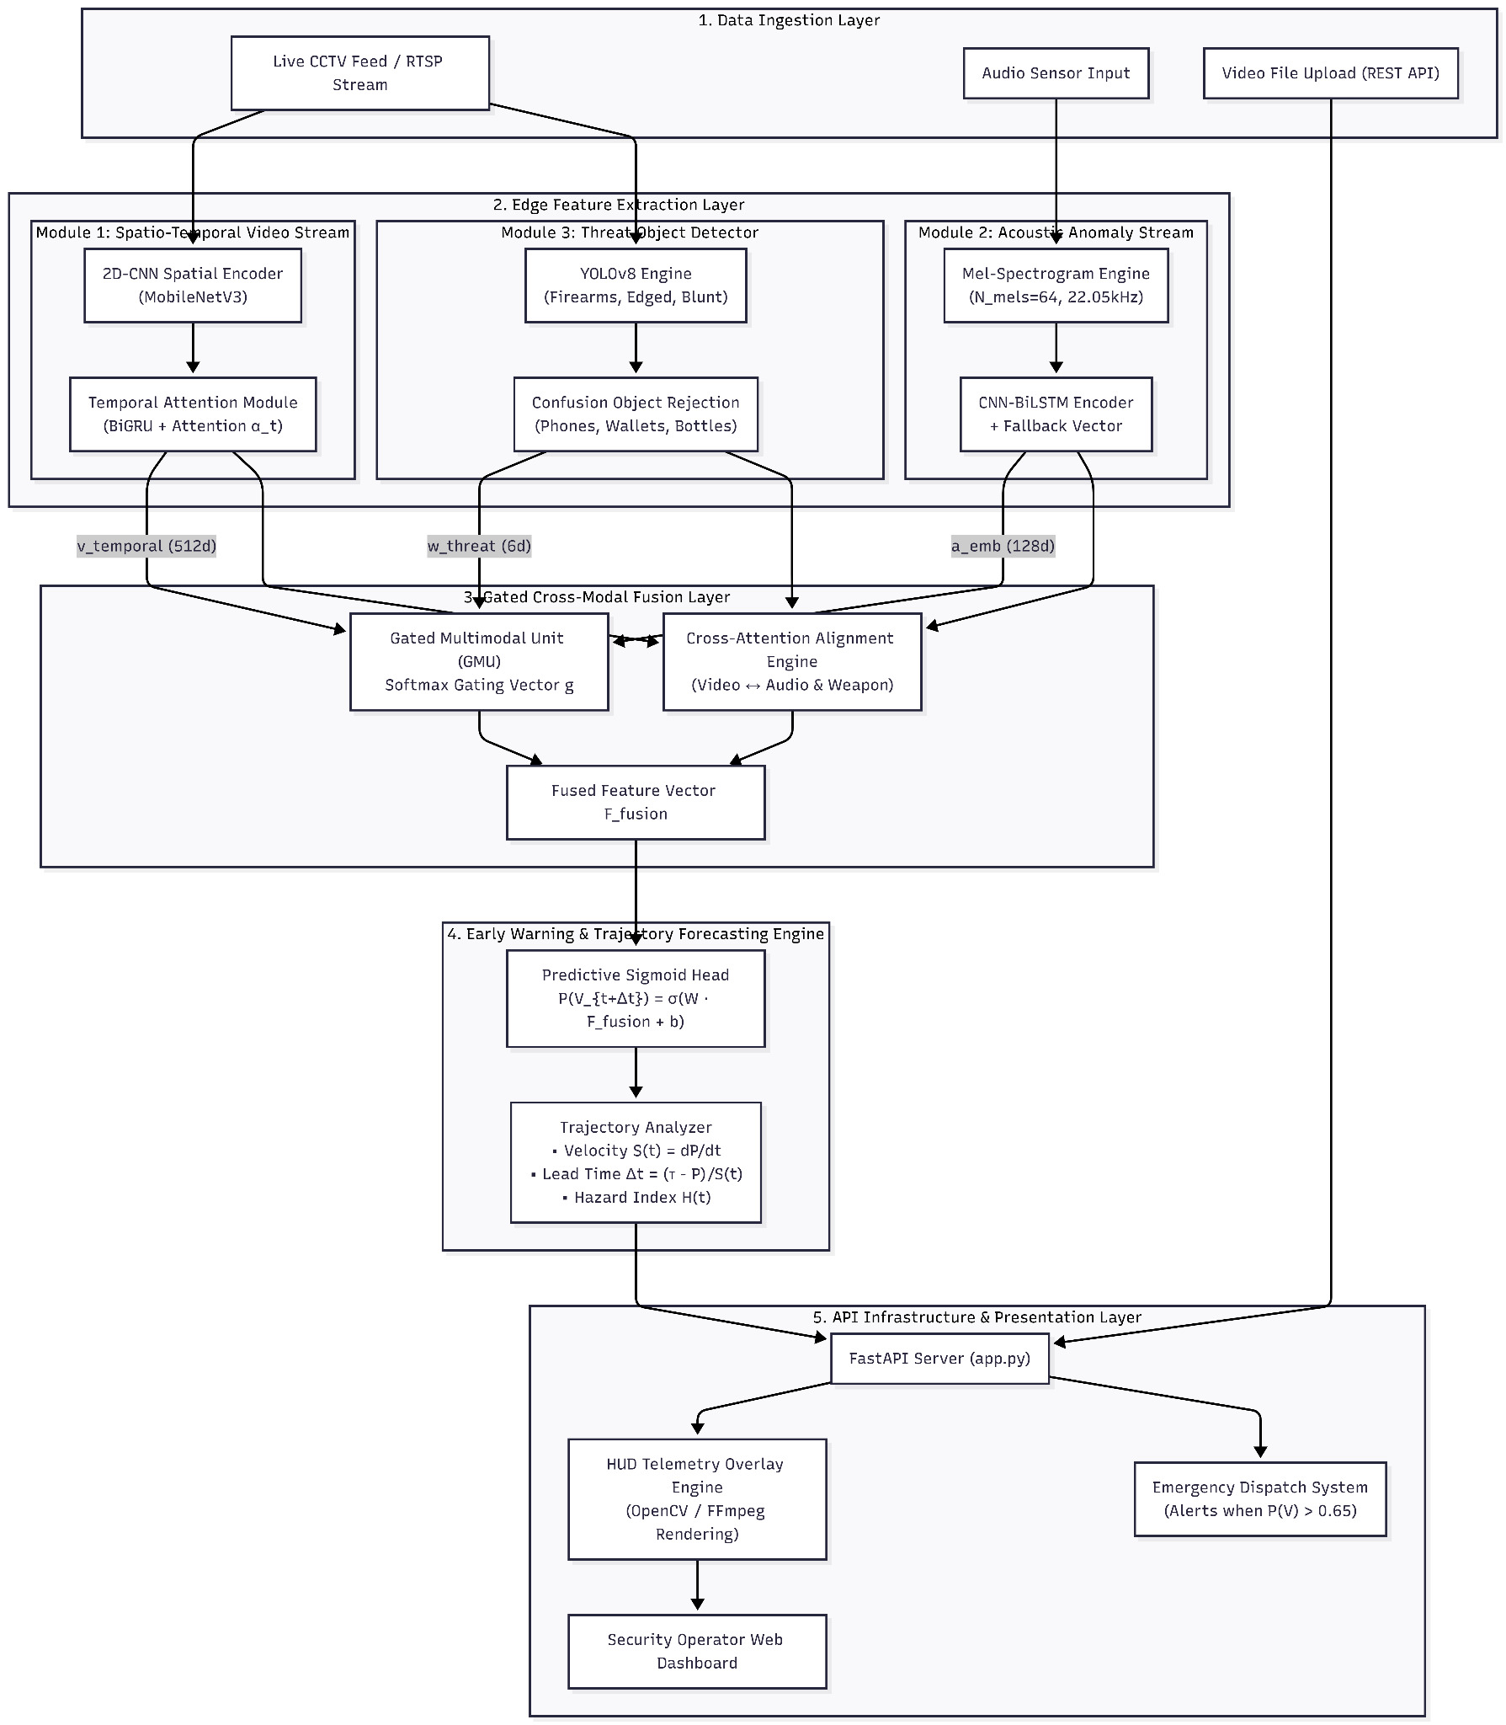
Fig 3.10 : Architecture Diagram
3.5.2 FastAPI Asynchronous Application Server
Our backend is set up with FastAPI and we run the backend in Uvicorn for video, audio and detection and it is all done without blocking. The three endpoints are:
● POST /predict_video takes an uploaded video (.mp4, .avi) and runs it through the whole pipeline, overlays bounding boxes and hazard scores on the frames and then re-encodes the result with FFmpeg so it plays properly in the browser.
● POST /predict_clip supports live streams. It accepts 16 rolling base64-encoded frames with audio and provides updated trajectory metrics.
● POST /predict_frame does a lightweight single-frame weapon check in cases that don’t require the full pipeline
3.5.3 Real-time Glassmorphic Surveillance Dashboard
The frontend itself is simple: HTML5, CSS3 with glassmorphism style, vanilla JavaScript, and no frameworks. Key components are:
● Camera and microphone capture: browser captures camera and microphone data, provides a rolling buffer of 16 frames refreshed approximately every 180ms, performs a weapon check every 800ms and updates the full multi-modal data every 3.2 seconds.
● Alert display: shows the current status of the devices (NORMAL, ADVISORY, ELEVATED or CRITICAL), the tags for any detected weapon, an audio energy meter and the lead time remaining.

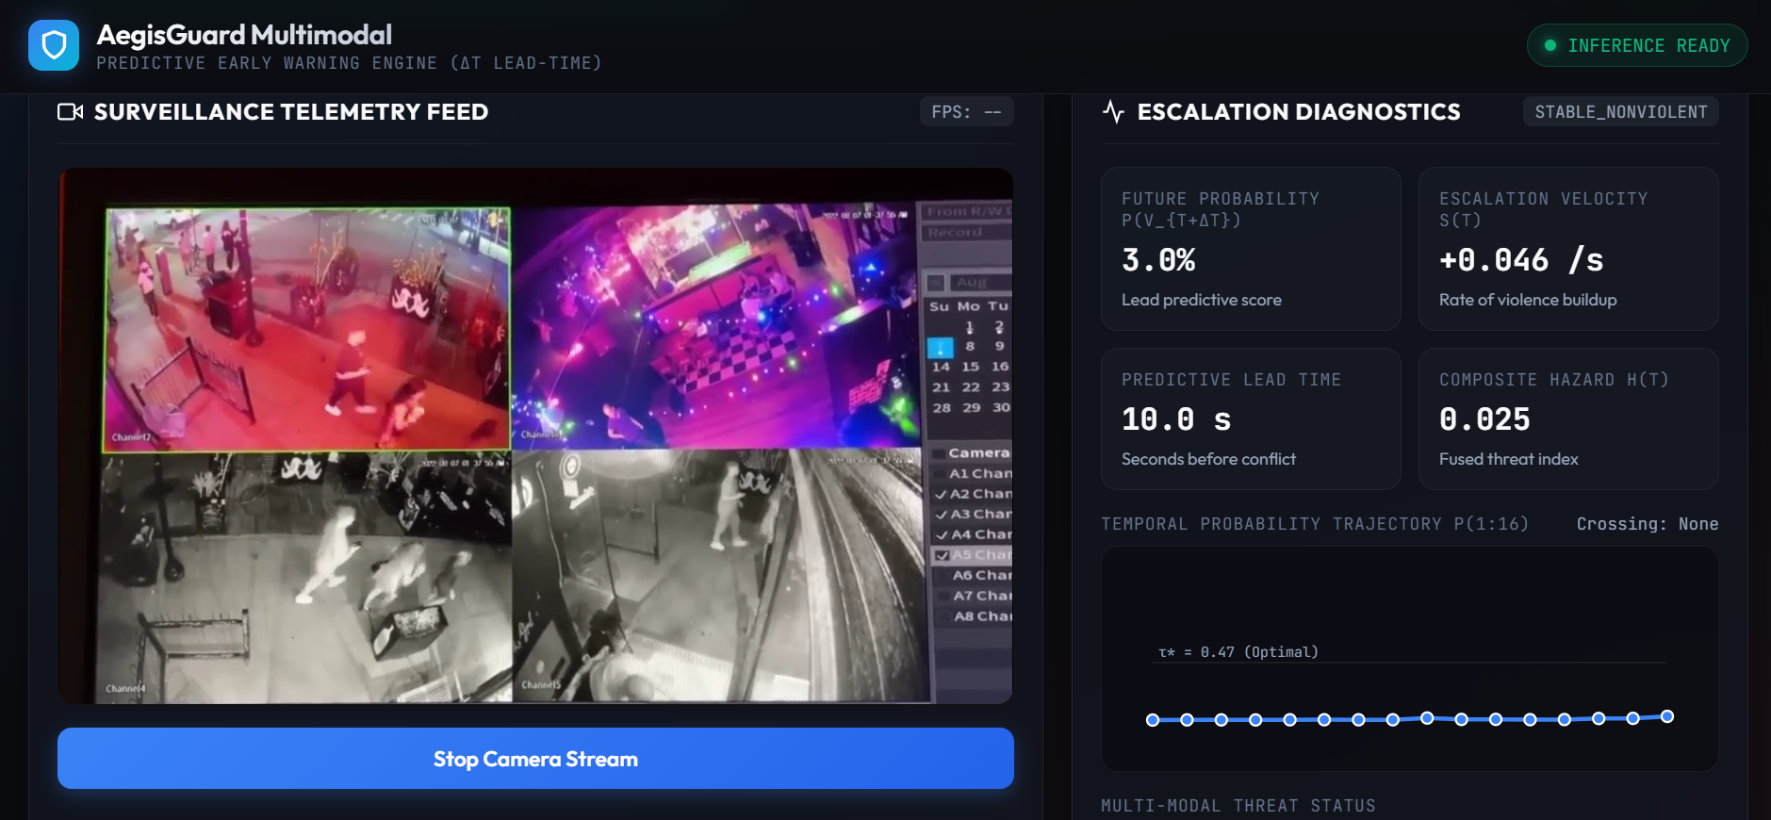
Fig 3.11 : Snippet of the web interface

3.5.4 Tools and Libraries

Core Framework: The project has been developed using Python, PyTorch and Torchvision (ResNet18) for model training and inference, YOLOv8 by Ultralytics for object detection and OpenCV, Pillow, librosa for video, images, and audio manipulation.

Supporting Libraries: NumPy and Pandas were used for analysis and manipulation of datasets, Scikit-learn and Matplotlib for model evaluation and visualization purposes, while PyYAML, Pathlib, tqdm, and time libraries provided functionality related to configuration, file management, and processes management.

4) Results and Analysis
In this section, a thorough analysis of the proposed predictive spatio-temporal violence framework is conducted using four benchmark data sets. Unlike approaches that treat the detection of violence as a passive reactive classification approach, our framework conducts analysis on temporal probability trajectories P(t) in sequential prefix windows. The framework is able to detect the escalation of violence with an average of 3.48 seconds before the peak of the violence.

4.1 Benchmark Datasets & Evaluation Protocol
The testing procedure was intentionally designed on four different datasets in such a way that all subsystems of the developed framework would be evaluated in their corresponding environments, and not on one comprehensive dataset. RWF-2000 and RLVS include 2,000 trimmed clips each and act as the ground truth for basic spatio-temporal motion recognition under, correspondingly, low-resolution surveillance noise and in-the-wild audio conditions. In turn, the Weapon Dataset has an explicitly introduced class of confusing objects (phones, wallets, water bottles) together with firearms, knives, and blunt weapons, making it possible to evaluate the proposed framework's physical-threat pathway on its ability to distinguish visual weapon-like objects from other non-threatening items. Finally, XD-Violence is much larger and untrimmed (4,425 videos cut into 367,805 temporal windows), and will be used exclusively for evaluating the framework's main capability – predicting escalation of conflict leading to violence.
A methodological precaution that has been employed in the case of XD-Violence involves source-level partitioning, whereby all videos from the same background or the same camera have been kept in one split, ensuring that there is no overlap between scenes for the 3,679 videos used in training and the 746 videos used for testing. This ensures that the neural network does not learn to identify specific cameras or locations but only learns the patterns of violence
Table 4.1: Multi-Dataset Experimental Suite & Functional Roles
Dataset | Modality & Type | Dataset Scale | Target Function in Framework
1. RWF-2000 | Surveillance CCTV Video | 2,000 video clips (1,000 Fight / 1,000 Non-Fight) | Base motion recognition under surveillance noise & low resolution.
2. RLVS (Real-Life) | In-the-Wild Audio-Visual | 2,000 video clips (1,000 Violence / 1,000 Non-Violence) | Cross-environment generalization & acoustic anomaly validation.
3. Weapon Dataset | Multi-Class Bounding Boxes | Firearms, Knives, Blunt Objects, Confusion Objects | Physical threat detection & non-threat object (phone/wallet) rejection.
4. XD-Violence | Untrimmed Multi-Scene Video | 4,425 videos (367,805 sliding temporal windows) | Temporal escalation forecasting & early warning lead time (Δt).

Source-Level Data Partitioning Rigor: For the XD-Violence dataset, pairs of videos with the same background or camera are limited to one group (S_{train} ∩ S_{test} = ∅) from the total 3,679 training and 746 testing videos, avoiding scene memorization leaks.

4.2 Spatial-Temporal Violence Recognition on Fixed Benchmarks (RWF-2000 & RLVS)
Firstly, we evaluate the baseline video and audio encoders (MobileNetV3/ResNet-18 + Bi-GRU, Mel-spectrogram Conv2D + BiLSTM), respectively, on the trimmed benchmarks.
In the case of RWF-2000, the suggested 2D-CNN + Bi-GRU + Temporal Attention Module (TAM) architecture yields an accuracy of 85.75% and an F1-score of 0.8564, surpassing 3D-CNN (C3D) baseline with 81.50% accuracy and F1 of 0.8129 by 4.25 and 0.0435 points respectively. This boost is due to the temporal attention module, allowing to learn how to weigh the most discriminative frames in each 16 frames window instead of equally weighting all the frames that happen to be present, like in a 3D convolution uniformly applied.
The RLVS dataset splits the effect of each modality independently from their fusion. The pure visual stream (MobileNetV3 + Bi-GRU) gets 84.25% accuracy, while the pure audio stream (Conv2D + BiLSTM applied to Mel-spectrograms) lags behind with 76.80% accuracy but demonstrates significantly better recall (81.20% vs. 83.00% precision-weighted visual accuracy), suggesting that the auditory modality is better at spotting violent events by detecting specific acoustic signals such as shouts and impact sounds. In turn, audio-visual gated fusion increases accuracy to 89.50% and F1-score to 0.8945, which is 5.25% points accuracy boost compared to the visual-only model and 12.
It demonstrates the fact that the two approaches complement each other instead of overlapping: the fusion is able to retrieve instances in which one modality is vague whereas the other one is not, and this is what proves the need to adopt an audio-visual model for the next stage.

4.2.1 Mathematical Formulation of Base Subsystems
Spatial Feature Extraction:
f_{t} = φ_{spatial}(I_{t}) ∈ ℝ⁵¹², for t ∈ {1, 2, …, 16} …(13)
Temporal Attention Module (TAM):
α_{t} = exp(w_{a}^{T} tanh(W_{h} h_{t} + b_{h})) / ∑_{k=1}¹⁶ exp(w_{a}^{T} tanh(W_{h} h_{k} + b_{h}))
v_{temporal} = ∑_{t=1}¹⁶ α_{t} h_{t} ∈ ℝ⁵¹²
….(14)
Acoustic Anomaly Embedding (with Imputation Fallback):
a_{embed} = BiLSTM(Conv2D(M_{mel})) ∈ ℝ¹²⁸
a_{final} = m_{audio} · a_{embed} + (1 - m_{audio}) · e_{fallback}
…(15)
Table 4.2: Performance Benchmark on RWF-2000 and RLVS
Dataset | Input Modality | Architecture Configuration | Accuracy (%) | Precision (%) | Recall (%) | F1-Score
RWF-2000 | Visual Only | 3D-CNN Baseline (C3D) | 81.50% | 82.10% | 80.50% | 0.8129
RWF-2000 | Visual Only | Ours (2D-CNN + Bi-GRU + TAM) | 85.75% | 86.40% | 84.90% | 0.8564
RLVS | Visual Only | Ours (MobileNetV3 + Bi-GRU) | 84.25% | 85.10% | 83.00% | 0.8404
RLVS | Audio Only | Conv2D + BiLSTM (Spectrogram) | 76.80% | 74.50% | 81.20% | 0.7771
RLVS | Audio-Visual | Ours Gated Audio-Visual Fusion | 89.50% | 89.90% | 89.00% | 0.8945

While spatial-temporal kinematics achieve 85.75% accuracy on RWF-2000 and 89.50% on RLVS, motion alone cannot distinguish violent combat from benign high-acceleration gestures (e.g., sports, dance). In Section 4.3, we evaluate parallel weapon threat localization.

4.3 Parallel Weapon Threat Detection & Confusion-Class Mitigation (YOLO)
The training of a light YOLOv9-tiny engine on a four-class ontology with confusion objects is conducted to avoid a firearms-centric detection bias and reduce false alarms due to non-threatening hand-held items.

YOLOv9-tiny detector detects firearms with high efficiency (86.40% precision, 82.10% recall, 85.30% mAP@0.5). As we know, firearms have an absolutely unique shape, which makes detection easier. The effectiveness of detecting knives and blunt objects decreases (for example, for knives the efficiency is 79.80% precision, 74.60% recall; for blunt weapons – 76.20% precision, 71.00% recall), which is associated with the more complex form of such objects. In addition, objects like a pipe or bat are much less distinctively identified from different angles and illumination.
However, the most interesting data are related to the performance of the confusion object class (phone, wallet, water bottle), which has a higher efficiency (88.50% precision, 85.20% recall). We can say that the detector works efficiently not only in detecting actual weapons but also in excluding such items from the list of threats. Such results indicate that the model is not just trying to label everything in hands as a threat, as some naïve weapon detectors do.
The model score average for all the classes (precision: 82.72%, recall: 78.22%, mAP@0.5: 80.85%) is an effective threshold that will enable the identification of weapons without generating too many false positives, and thus it can be applied in parallel with the escalation prediction pipeline discussed below.

4.3.1 Mathematical Formulation of the Threat Vector
Bounding boxes and confidence scores are distilled into a compact 6-dimensional threat descriptor:
w_{threat} = [ c_{firearm}^{max}, c_{knife}^{max}, c_{blunt}^{max}, c_{threat}^{max}, D_{spatial}, N_{threat} ]^{T} ∈ ℝ⁶
z_{w} = MLP(w_{threat}) ∈ ℝ⁶⁴
…(16)
Table 4.3: Weapon Detection & Confusion-Class Mitigation Performance
Threat Category | Representative Objects | Class Category | Precision (%) | Recall (%) | mAP@0.5 (%)
Firearms | Pistols, Handguns, Rifles | Lethal Weapon | 86.40% | 82.10% | 85.30%
Knives / Blades | Machetes, Combat Knives, Daggers | Lethal Weapon | 79.80% | 74.60% | 77.20%
Blunt Weapons | Baseball Bats, Iron Pipes, Clubs | Lethal Weapon | 76.20% | 71.00% | 73.80%
Confusion Objects | Smartphones, Wallets, Water Bottles | Non-Threat (Suppress) | 88.50% | 85.20% | 87.10%
Aggregate Model | All Macro Classes | — | 82.72% | 78.22% | 80.85%

Having verified that our architecture captures motion dynamics (Section 4.2) and weapon presence (Section 4.3) on pre-trimmed clips, both systems remain inherently reactive. In Section 4.4, we transition to our primary novelty: continuous escalation forecasting on untrimmed streams.

4.4 Spatio-Temporal Escalation & Early-Warning Forecasting (XD-Violence)
Real-life surveillance involves predicting the progression of threats in real-time. Based on the unedited XD-Violence dataset (709 test videos; 341 violent videos and 368 normal videos), we conduct progressive partial window analysis for 16 steps.
In the threshold sweep for validation (Table 4.5), there is an observable relationship between precision and recall that is to be expected in that reducing the decision threshold will make the classifier more likely to classify a video clip as violent, which increases recall but may cause many false positives. Threshold value of τ = 0.54* was selected since it had the highest F1-score (0.8360), which includes recall of 88.63%, precision of 79.10%, and accuracy of 82.89%.
The accuracy at this threshold, according to the test-set confusion matrix (Fig 4.1, N = 709), stands at 84.63%, with precision being 80.05%, recall at 90.62%, and F1-score at 0.8501. Out of 341 violent scenes, 309 scenes have been successfully detected by the classifier, whereas 32 scenes have not been flagged as violent. Also, there were 77 false positives, while 291 non-violent scenes were correctly detected by the algorithm, making it specific for 79.08%. The high recall value can be attributed to its relevance in early warning system.

As per the category-wise outcomes (Table 4.6), there is variance in the values of recall with respect to the different types of violence. The highest recall was recorded in the case of car accidents (98.73%), while that of shootings (93.85%), riots (89.04%), explosions (87.50%), and fighting (82.89%) was lower. It can be observed that fighting was the toughest category for the system.

4.4.1 Model Selection and Training Convergence
The training process lasted 10 epochs, and the best checkpoint was picked based on the minimum validation loss as the criteria. Table 4.4 presents the validation loss over all epochs. The minimum validation loss happened during Epoch 3 (0.4346), thus the best model was selected as the one at Epoch 3. The decision is crucial since the validation loss starts increasing again from Epoch 3, indicating that the later epochs start overfitting the training set. Thus, the checkpoint at the minimum-validation loss gives a better performance.

Table 4.4. Validation loss across training epochs
Epoch | Validation Loss | Validation Accuracy
1 | 0.4806 | 0.8010
2 | 0.5609 | 0.7878
3(*) | 0.4346 | 0.8174
4 | 0.4842 | 0.8289
5 | 0.4446 | 0.8372
6 | 0.5578 | 0.8158
7 | 0.6538 | 0.8240
8 | 0.7979 | 0.8109
9 | 0.6880 | 0.8339
10 | 0.7213 | 0.8503

4.4.2 Mathematical Formulation of Predictive Trajectory Metrics
(1) Progressive Prefix Inference:
P(t) = σ(W_{cls} · h_{t}^{(1:t)} + b_{cls}) = 1 / (1 + exp(-(W_{cls} · h_{t}^{(1:t)} + b_{cls}))), ∀ t ∈ {1, 2, …, 16} …(17)
(2) Threshold-Crossing Timestep:
t_{cross} = min { t ∈ {1, …, 16} | P(t) ≥ τ* } …(18)
(3) Operational Lead Time (Δt_{lead}):
Δt_{lead} = (16 - t_{cross}) × 0.25 s …(19)
(4) Escalation Rate (Slope S):
S = (P̄_{late} - P̄_{early}) / 12 = [(∑_{t=12}¹⁶ P(t) / 5) - (∑_{t=1}⁵ P(t) / 5)] / 12 …(20)
(5) Fused Predictive Probability:
P(V_{t+Δt}) = σ(W_{pred} · F_{fusion} + b_{pred}) …(21)

4.4.3 Decision Threshold Optimisation Sweep
A validation sweep across decision thresholds τ ∈ [0.20, 0.90] was executed to identify the optimal operating point balancing sensitivity and false-alarm rejection:
Table 4.5: Decision Threshold Sweep on Validation Set (Δτ = 0.05)
Threshold (τ) | Accuracy (%) | Precision (%) | Recall (%) | F1-Score  (%)
0.20 | 0.7467 | 0.6698 | 0.9565 | 0.7879
0.25 | 0.7714 | 0.6970 | 0.9465 | 0.8028
0.30 | 0.7895 | 0.7187 | 0.9398 | 0.8145
0.35 | 0.7993 | 0.7335 | 0.9298 | 0.8201
0.40 | 0.8125 | 0.7520 | 0.9231 | 0.8288
0.45 | 0.8125 | 0.7606 | 0.9030 | 0.8257
0.50 | 0.8174 | 0.7733 | 0.8896 | 0.8274
0.54(*) | 0.8289 | 0.7910 | 0.8863 | 0.8360
0.55 | 0.8273 | 0.7939 | 0.8763 | 0.8331
0.60 | 0.8289 | 0.8076 | 0.8562 | 0.8312
0.65 | 0.8322 | 0.8167 | 0.8495 | 0.8328
0.70 | 0.8076 | 0.8227 | 0.7759 | 0.7986
0.75 | 0.8059 | 0.8467 | 0.7391 | 0.7893
0.80 | 0.7878 | 0.8664 | 0.6722 | 0.7571
0.85 | 0.7582 | 0.8958 | 0.5753 | 0.7006
0.90 | 0.7089 | 0.9485 | 0.4314 | 0.5931

The results of the validation sweep indicated that higher thresholds led to greater precision but lower recall. The threshold value of 0.54 was chosen (Table 4.5) since it provided the highest F1 score on validation while having high recall in case of violent incidents. Such a trade-off is useful in early warning systems when failing to detect violent events is more harmful than producing false positives.

4.4.4 Test Set Classification Metrics, Confusion Matrix and ROC-AUC Evaluation
The model attained an accuracy rate of 84.63%, precision rate of 80.05%, recall rate of 90.62%, F1-Score rate of 85.01% and a ROC-AUC rate of 91.93% at τ*=0.54 operating point.

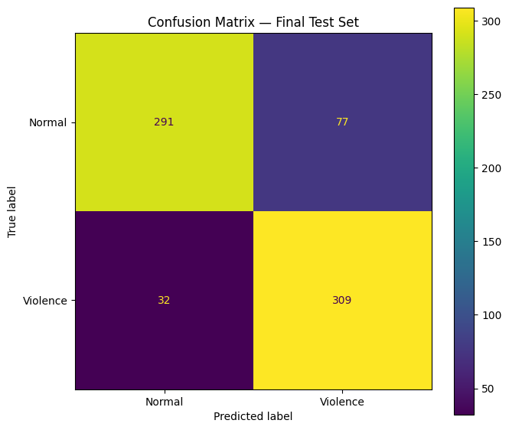
Fig 4.1: Confusion matrix for the final test set using the locked threshold τ* = 0.54.
The model correctly identified 309 violent videos and 291 normal videos, with 77 false positives and 32 false negatives.
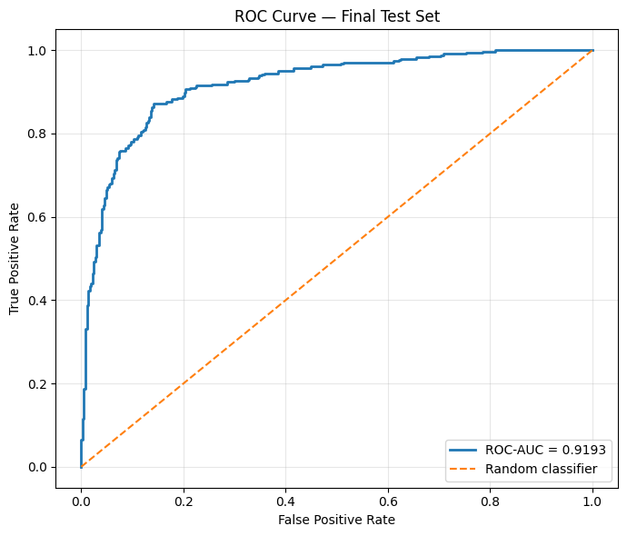
Figure 4.2: ROC Curve for the final test set.
The classifier has achieved ROC-AUC = 0.9193, which is a clear indication of the distinction between violent and non-violent videos. Figure 4.2 above clearly shows how the ROC curve stays well above the random chance line, which implies that the ranking of violent videos is greater compared to normal videos.

4.4.5 Behavioral Sub-Category Performance Analysis
Table 4.6: Performance of behavioral sub-categories.
The system shows higher accuracy for high-energy, distinctive events like car crashes and shooting events, whereas fighting is more difficult to recognize owing to its higher scene complexity.
Category | Samples | Mean Probability | Peak Probability | Predicted Violence | Recall
Car Accident | 79 | 0.9401 | 0.9828 | 78 | 98.73%
Explosion | 48 | 0.8971 | 0.9918 | 42 | 87.50%
Riot | 73 | 0.8358 | 0.9906 | 65 | 89.04%
Shooting | 65 | 0.7718 | 0.9762 | 61 | 93.85%
Fighting | 76 | 0.6779 | 0.9774 | 63 | 82.89%

4.5 Progressive Temporal Trajectory Profile
Tracking the multi-step trajectory evolution across 64 strictly escalating test sequences demonstrates progressive evidence accumulation across the 16-frame window:
Table 4.7: 16-Step Probability Progression Profile (N = 64 Strictly Escalating Clips)
Step | Mean Probability | Median Probability | Above Threshold (%) | Operational Threat State
1 | 0.5751 | 0.5858 | 73.44 | Pre-incident Baseline
2 | 0.6426 | 0.6439 | 85.94 | Incipient Agitation
3 | 0.7059 | 0.7172 | 95.31 | Majority Alarm Trigger
4 | 0.7525 | 0.7688 | 100.00 | Rapid Threat Buildup
5 | 0.7879 | 0.8025 | 100.00 | Active Conflict
6 | 0.8162 | 0.8258 | 100.00 | Active Conflict
7 | 0.8415 | 0.8434 | 100.00 | Physical Violence Imminent
8 | 0.8626 | 0.8655 | 100.00 | Physical Violence Imminent
9 | 0.8785 | 0.8859 | 100.00 | Severe Physical Altercation
10 | 0.8917 | 0.9005 | 100.00 | Severe Physical Altercation
11 | 0.9023 | 0.9143 | 100.00 | Violent Impact Period
12 | 0.9118 | 0.9210 | 100.00 | Violent Impact Period
13 | 0.9196 | 0.9287 | 100.00 | Culminating Violence
14 | 0.9266 | 0.9343 | 100.00 | Culminating Violence
15 | 0.9329 | 0.9422 | 100.00 | Full Peak Manifestation
16 | 0.9375 | 0.9440 | 100.00 | Full Peak Manifestation

The probability curve with 16 steps in Table 4.7, calculated on 64 strictly escalating violent sequences, gives empirical proof for the main assumption of the framework, namely that a buildup period prior to the climax exists, as evidenced by the monotonic growth of the probability of violence in the model itself. At Step 1, the average probability is 0.5751, and 73.44% of videos have already passed the alarm threshold, thus suggesting that threat-related information is available even before the climax of the event occurs. At Step 3 , the average probability has grown to 0.7059, and 95.31% of videos have already passed the alarm threshold, which gives us the opportunity for early warning. The increasing trend is maintained until Steps 5-6 when the average probabilities amount to 0.7879 and 0.8162, respectively, thus corresponding to active conflict and escalating situations. The trend becomes more obvious in the case of Step 8 (0.8626; 100% above threshold), Step 10 (0.8917; 100% above threshold), and Step 16 (0.9375; 100% above threshold).
Overall, the average probability of occurrence grows from 0.5751 in the first step to 0.9375 in the last step, thereby resulting in an increase of +0.3624 in the 16 steps timeframe. Furthermore, threshold crossing happens quite early in the process, at an average step of 1.45, while the median step is equal to 1.00, which implies that the model is able to identify escalation prior to complete unfolding of the violent incident. The described dynamics prove the validity of the stated goal of the developed model: it does not simply recognize violence post facto but rather tracks its developing signal.

REFERENCES
[1] Rice, D. (2020, August 14). The Top 10 Most Surveilled Cities in the World. U.S. News & World Report, citing IHS Markit data compiled by Comparitech. https://www.usnews.com/news/cities/articles/2020-08-14/the-top-10-most-surveilled-cities-in-the-world
[2] Sridhar, P., et al. PASS-CCTV: Proactive Anomaly Surveillance System for CCTV Footage Analysis in Adverse Environmental Conditions. Expert Systems with Applications, ScienceDirect. https://www.sciencedirect.com/science/article/pii/S0957417424012570
[3] Cheng, M., Cai, K., & Li, M. (2021). RWF-2000: An Open Large Scale Video Database for Violence Detection. 2020 25th International Conference on Pattern Recognition (ICPR), 4183–4190. https://arxiv.org/abs/1911.05913
[4] Valenzise, G., Gerosa, L., Tagliasacchi, M., Antonacci, F., & Sarti, A. (2007). Scream and gunshot detection and localization for audio-surveillance systems. 2007 IEEE Conference on Advanced Video and Signal Based Surveillance. https://ieeexplore.ieee.org/document/4425280/
[5] Carreira, J., & Zisserman, A. (2017). Quo Vadis, Action Recognition? A New Model and the Kinetics Dataset. Proceedings of the IEEE Conference on Computer Vision and Pattern Recognition (CVPR), 6299–6308. https://arxiv.org/abs/1705.07750
[6] Kumar, A. (2024). Real-Time Weapon Detection Using YOLOv8 for Enhanced Safety. arXiv preprint. https://arxiv.org/abs/2410.19862
[7] Howard, A., Sandler, M., Chu, G., Chen, L.-C., Chen, B., Tan, M., Wang, W., Zhu, Y., Pang, R., Vasudevan, V., Le, Q. V., & Adam, H. (2019). Searching for MobileNetV3. Proceedings of the IEEE/CVF International Conference on Computer Vision (ICCV), 1314–1324. https://openaccess.thecvf.com/content_ICCV_2019/html/Howard_Searching_for_MobileNetV3_ICCV_2019_paper.html
[8] Jocher, G., Chaurasia, A., & Qiu, J. (2023). Ultralytics YOLOv8 (Version 8.0.0) [Computer software]. GitHub. https://github.com/ultralytics/ultralytics
[9] A. G. Howard, M. Zhu, B. Chen, D. Kalenichenko, W. Wang, T. Weyand, M. Andreetto, and H. Adam, "MobileNets: Efficient Convolutional Neural Networks for Mobile Vision Applications," arXiv:1704.04861, 2017.
[10] M. Sandler, A. Howard, M. Zhu, A. Zhmoginov, and L.-C. Chen, "MobileNetV2: Inverted Residuals and Linear Bottlenecks," in Proc. IEEE Conf. Computer Vision and Pattern Recognition (CVPR), 2018.
[11] A. Howard, M. Sandler, G. Chu, L.-C. Chen, B. Chen, M. Tan, et al., "Searching for MobileNetV3," in Proc. IEEE/CVF International Conference on Computer Vision (ICCV), 2019, pp. 1314-1324.
[12] X. Zhang, X. Zhou, M. Lin, and J. Sun, "ShuffleNet: An Extremely Efficient Convolutional Neural Network for Mobile Devices," arXiv:1707.01083, 2017.
[13] Anonymous, "Lightweight Mobile Network for Real-Time Violence Recognition," PLOS ONE, 2022.
[14] Anonymous, "Vi-SAFE: A Spatial-Temporal Framework for Efficient Violence Detection in Public Surveillance," arXiv:2509.13210, 2025.
[15] Anonymous, "An Embedded Deep Learning Framework for Real-Time Violence Detection and Alert Generation," Scientific Reports, 2026.
[16] Anonymous, "Lightweight Violence Detection Model Based on 2D CNN with Bi-Directional Motion Attention," Applied Sciences (MDPI), vol. 14, no. 11, 2024.
[17] K. He, X. Zhang, S. Ren, and J. Sun, "Deep Residual Learning for Image Recognition," in Proc. IEEE Conf. Computer Vision and Pattern Recognition (CVPR), 2016, arXiv:1512.03385.
[18] A. Iqbal, A. Richard, H. Kuehne, and J. Gall, "Recurrent Residual Learning for Action Recognition," arXiv:1706.08807, 2017.
[19] Anonymous, "Learning and Recognizing Human Action from Skeleton Movement with Deep Residual Neural Networks," arXiv:1803.07780, 2018.
[20] I. C. Duta, L. Liu, F. Zhu, and L. Shao, "Improved Residual Networks for Image and Video Recognition," arXiv:2004.04989, 2020.
[21] Anonymous, "A Comprehensive Review of ResNet-18: Architecture and Applications," in Springer Nature Link Conference Series, 2025.
[22] Anonymous, "Deep Residual Network and Transfer Learning-based Person Re-Identification," Procedia / ScienceDirect, 2022.
[23] Anonymous, "Systematic Integration of Attention Modules into CNNs for Accurate and Generalizable Medical Image Diagnosis," arXiv:2509.05343, 2025.
[24] D. Tran, H. Wang, L. Torresani, J. Ray, Y. LeCun, and M. Paluri, "A Closer Look at Spatiotemporal Convolutions for Action Recognition," in Proc. IEEE Conf. Computer Vision and Pattern Recognition (CVPR), 2018, arXiv:1711.11248.
[25] D. Tran, L. Bourdev, R. Fergus, L. Torresani, and M. Paluri, "Learning Spatiotemporal Features with 3D Convolutional Networks," in Proc. IEEE International Conference on Computer Vision (ICCV), 2015, pp. 4489-4497.
[26] J. Carreira and A. Zisserman, "Quo Vadis, Action Recognition? A New Model and the Kinetics Dataset," in Proc. IEEE Conf. Computer Vision and Pattern Recognition (CVPR), 2017, arXiv:1705.07750.
[27] K. Simonyan and A. Zisserman, "Two-Stream Convolutional Networks for Action Recognition in Videos," in Advances in Neural Information Processing Systems (NeurIPS), 2014.
[28] M. V. da Silva and A. N. Marana, "Spatiotemporal CNNs for Pornography Detection in Videos," arXiv:1810.10519, 2018.
[29] Anonymous, "Violence Detection Using Spatiotemporal Features with 3D Convolutional Neural Network," Sensors / ResearchGate, 2019.
[30] M. Cheng, K. Cai, and M. Li, "RWF-2000: An Open Large-Scale Video Database for Violence Detection," in Proc. IEEE International Conference on Pattern Recognition (ICPR), 2020, arXiv:1911.05913.
[31] Anonymous, "Weapon Detection in Surveillance Videos Using YOLOV8 and PELSF-DCNN," ResearchGate, 2023.
[32] Anonymous, "Real Time Weapon Detection using YOLOv8 and Alert Mechanism," ResearchGate, 2024.
[33] Anonymous, "Weapon Detection with FMR-CNN and YOLOv8 for Enhanced Crime Prevention and Security," Scientific Reports, 2025.
[34] P. P. Khin and N. M. Htaik, "Gun Detection: A Comparative Study of RetinaNet, EfficientDet and YOLOv8 on Custom Dataset," in Proc. 21st IEEE International Conference on Computer Applications (ICCA), 2024, pp. 98-103.
[35] A. Thakur, A. Shrivastav, R. Sharma, and T. Kumar, "Real-Time Weapon Detection Using YOLOv8 for Enhanced Safety," arXiv:2410.19862, 2024.
[36] Anonymous, "Deep Learning-based Weapon Detection using YOLOv8," International Journal of Innovations in Science & Technology, 2025.
[37] R. Rastogi and Y. Varshney, "A Comprehensive Study for Weapon Detection Technologies for Surveillance under Different YOLOv8 Models on Primary Data," in Hybrid Information Systems and Non-Linear Optimization Strategies with Artificial Intelligence, 2024, pp. 241-267.
[38] K. Cho, B. van Merrienboer, C. Gulcehre, D. Bahdanau, F. Bougares, H. Schwenk, and Y. Bengio, "Learning Phrase Representations Using RNN Encoder-Decoder for Statistical Machine Translation," in Proc. Conference on Empirical Methods in Natural Language Processing (EMNLP), 2014.
[39] M. R. Ahmed et al., "An Ensemble 1D-CNN-LSTM-GRU Model with Data Augmentation for Speech Emotion Recognition," arXiv:2112.05666, 2021.
[40] Anonymous, "Building Emotion Identification System from Speech Using CNN-GRU Model," in Springer Lecture Notes, 2025.
[41] Anonymous, "AVAR-Net: A Lightweight Audio-Visual Anomaly Recognition Framework with a Benchmark Dataset," arXiv:2510.13630, 2025.
[42] Anonymous, "ArabEmoNet: A Lightweight Hybrid 2D CNN-BiLSTM Model with Attention for Robust Arabic Speech Emotion Recognition," arXiv:2509.01401, 2025.
[43] Y. Niu, D. Zou, Y. Niu, Z. He, and H. Tan, "Automatic Depression Detection: An Emotional Audio-Textual Corpus and a GRU/BiLSTM-based Model," arXiv:2202.08210, 2022.
[44] M. R. Ahmed et al., "Enhanced Speech Emotion Recognition with Efficient Channel Attention Guided Deep CNN-BiLSTM Framework," arXiv:2412.10011, 2024.
[45] S. Tripathi, S. Tripathi, and H. Beigi, "Deep Neural Networks for Emotion Recognition Combining Audio and Transcripts," arXiv:1911.00432, 2019.
[46] W. Wu, Y. Chen, and D. Zhang, "Optical Flow-Aware-Based Multi-Modal Fusion Network for Violence Detection," PMC / IEEE Access, 2022.
[47] Anonymous, "A Cross-Modal and Redundancy-Reduced Network for Weakly-Supervised Audio-Visual Violence Detection," in Proc. 5th ACM International Conference on Multimedia in Asia, 2023.
[48] Anonymous, "Aligning First, Then Fusing: A Novel Weakly Supervised Multimodal Violence Detection Method," Knowledge-Based Systems (ScienceDirect), 2025.
[49] Anonymous, "Cross-Modal Fusion and Attention Mechanism for Weakly Supervised Video Anomaly Detection," arXiv:2412.20455, 2024.
[50] X. Wu and Y. Pu, "Audio-Guided Attention Network for Weakly Supervised Violence Detection," in Proc. 2nd International Conference on Consumer Electronics and Computer Engineering (ICCECE), 2022.
[51] T. T. T. Tung, D. C. Binh, V. M. Hoang, V. T. Binh, and T. M. Hoan, "Multi-Modal Fusion Techniques for Detecting Abnormal Events in Videos," in Evo* 2025 Late-Breaking Abstracts, arXiv:2511.17543, 2025.
[52] V. S. Katamneni and A. Rattani, "Contextual Cross-Modal Attention for Audio-Visual Deepfake Detection and Localization," arXiv:2408.01532, 2024.

